# AUTISM PREDICTION USING MACHINE LEARNING

# SOURCE CODE:

1. **Importing the dependencies**

import numpy as np

import pandas as pd

import matplotlib.pyplot as plt

import seaborn as sns

from sklearn.preprocessing import LabelEncoder

from imblearn.over_sampling import SMOTE

from sklearn.model_selection import train_test_split, cross_val_score, RandomizedSearchCV

from sklearn.tree import DecisionTreeClassifier

from sklearn.ensemble import RandomForestClassifier

from xgboost import XGBClassifier

from sklearn.metrics importaccuracy_score, confusion_matrix, classification_rImporting the dependencies

eport

import pickle

**2.Data Loading & Understanding**

# read the csv data to a pandas dataframe

df = pd.read_csv("/content/train.csv")

**Initial Inspection**

df.shape

df.tail()

# display all columns of a dataframe

pd.set_option('display.max_columns', None)

df.info()

# convert age column datatype to integer

df["age"] = df["age"].astype(int)

df.head(2)

# dropping ID & age_desc column

df = df.drop(columns=["ID", "age_desc"])

df.shape

df.head(2)

df.columns

df["contry_of_res"].unique()

# define the mapping dictionary for country names

mapping ={"Viet Nam": "Vietnam","AmericanSamoa": "United States","Hong Kong": "China"

}

# repalce value i    n the country column

df["contry_of_res"] = df["contry_of_res"].replace(mapping)

df["contry_of_res"].unique()

# taget class distribution

df["Class/ASD"].value_counts()

**3.Exploratory Data Analysis (EDA)**

df.shape

df.columns

df.head(2)

df.describe()

**Univariate Analysis**

**Numerical Columns:**

**age result**

sns.set_theme(style="darkgrid")

**Distribution Plots**

# Histogram for "age"

sns.histplot(df["age"], kde=True)

plt.title("Distribution of Age")

# calculate mean and median

age_mean = df["age"].mean()

age_median = df["age"].median()

print("Mean:", age_mean)

print("Median:", age_median)

# Add vertical lines for mean and median

plt.axvline(age_mean, color="red", linestyle="--", label="Mean")

plt.axvline(age_median, color="green", linestyle="-", label="Median")

plt. legend()

plt.show()

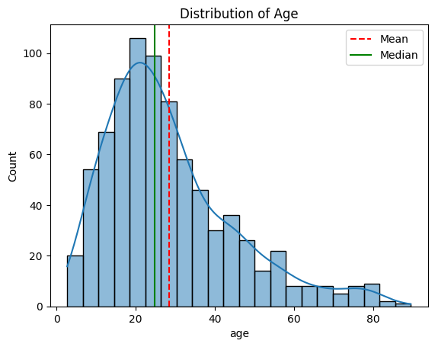

# Histogram for "result"

sns.histplot(df["result"], kde=True)

plt.title("Distribution of result")

# calculate mean and median

result_mean = df["result"].mean()

result_median = df["result"].median()

print("Mean:", result_mean)

print("Median:", result_median)

# add vertical lines for mean and median

plt.axvline(result_mean, color="red", linestyle="--", label="Mean")

plt.axvline(result_median, color="green", linestyle="-", label="Median")

plt.legend()

plt.show()

**Box plots for identifying outliers in the numerical columns**

# box plot

sns.boxplot(x=df["age"])

plt.title("Box Plot for Age")

plt.xlabel("Age")

plt.show()

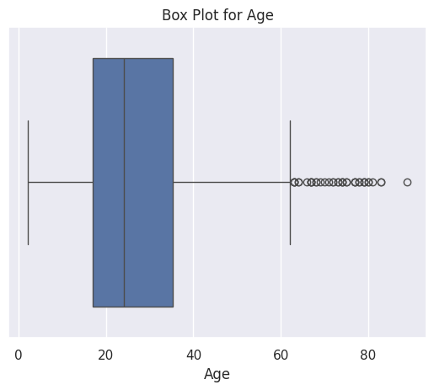

# box plot

sns.boxplot(x=df["result"])

plt.title("Box Plot for result")

plt.xlabel("result")

plt.show()

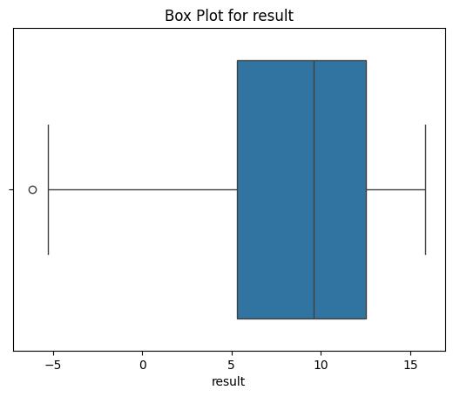

# count the outliers using IQR method

Q1 = df["age"].quantile(0.25)

Q3 = df["age"].quantile(0.75)

IQR = Q3 - Q1

lower_bound = Q1 - 1.5 * IQR

upper_bound = Q3 + 1.5 * IQR

age_outliers = df[(df["age"] < lower_bound) | (df["age"] > upper_bound)]

len(age_outliers)

# count the outliers using IQR method

Q1 = df["result"].quantile(0.25)

Q3 = df["result"].quantile(0.75)

IQR = Q3 - Q1

lower_bound = Q1 - 1.5 * IQR

upper_bound = Q3 + 1.5 * IQR

result_outliers = df[(df["result"] < lower_bound) | (df["result"] > upper_bound)]

len(result_outliers)

**Univariate analysis of Categorical columns**

df.columns

categorical_columns = ['A1_Score', 'A2_Score', 'A3_Score', 'A4_Score', 'A5_Score', 'A6_Score',

       'A7_Score', 'A8_Score', 'A9_Score', 'A10_Score', 'gender',

       'ethnicity', 'jaundice', 'austim', 'contry_of_res', 'used_app_before',

       'relation']

for col in categorical_columns:

  sns.countplot(x=df[col])

  plt.title(f"Count Plot for {col}")

plt.xlabel(col)

 plt.ylabel("Count")

 plt.show()

# countplot for target column (Class/ASD)

sns.countplot(x=df["Class/ASD"])

plt.title("Count Plot for Class/ASD")

plt.xlabel("Class/ASD")

plt.ylabel("Count")

plt.show()

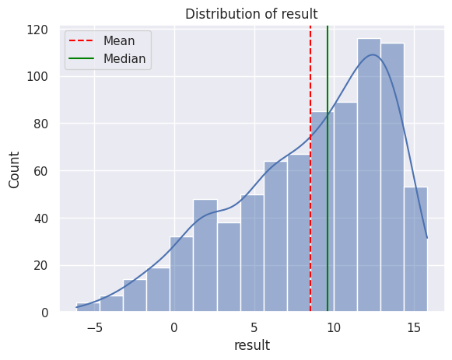

df["Class/ASD"].value_counts()

**handle missing values in ethnicity and relation column**

df["ethnicity"] = df["ethnicity"].replace({"?": "Others", "others": "Others"})

df["ethnicity"].unique()

df["relation"].unique()

df["relation"].unique()

df.head()

**Label Encoding**

# identify columns with "object" data type

object_columns = df.select_dtypes(include=["object"]).columns

print(object_columns)

# initialize a dictionary to store the encoders

encoders = {}

# apply label encoding and store the encoders

for column in object_columns:

  label_encoder = LabelEncoder()

  df[column] = label_encoder.fit_transform(df[column])

  encoders[column] = label_encoder   # saving the encoder for this column

# save the encoders as a pickle file

with open("encoders.pkl", "wb") as f:

pickle.dump(encoders, f)

encoders

df.head()

**Bivariate Analysis**

# correlation matrix

plt.figure(figsize=(15, 15))

sns.heatmap(df.corr(), annot=True, cmap="coolwarm", fmt=".2f")

plt.title("Correlation heatmap")

plt.show()

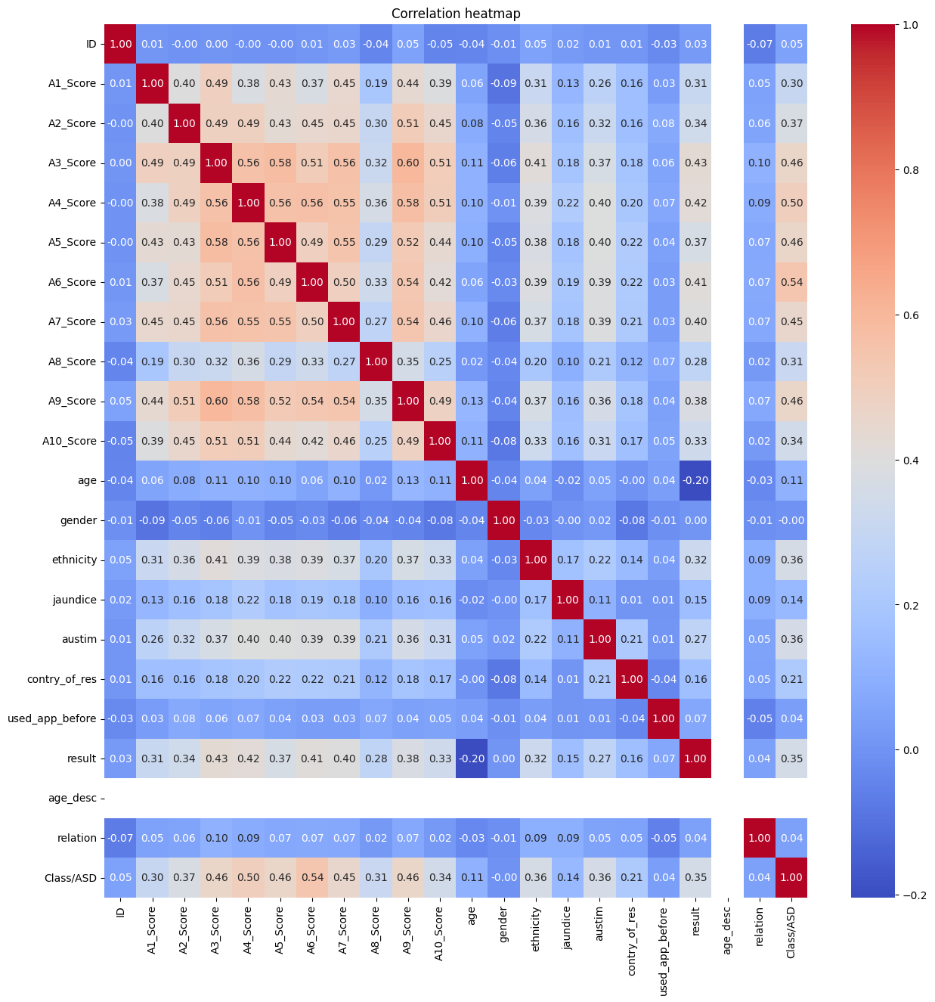

**4.Data preprocessing**

# function to replace the outliers with median

def replace_outliers_with_median(df, column):

Q1 = df[column].quantile(0.25)

Q3 = df[column].quantile(0.75)

IQR = Q3 - Q1

lower_bound = Q1 - 1.5 * IQR

upper_bound = Q3 + 1.5 * IQR

median = df[column].median()

# replace outliers with median value

df[column] = df[column].apply(lambda x: median if x < lower_bound or x > upper_bound else x)

return df

# replace outliers in the "age" column

df = replace_outliers_with_median(df, "age")

# re# evaluate on test data

**Train Test Split**

df.columns

X = df.drop(columns=["Class/ASD"])

y = df["Class/ASD"]

print(X)

print(y)

X_train, X_test, y_train, y_test = train_test_split(X, y, test_size=0.2, random_state=42)

print(y_train.shape)

print(y_test.shape)

y_train.value_counts()

y_test.value_counts()

**SMOTE (Synthetic Minority Oversampling technique)**

smote = SMOTE(random_state=42)

X_train_smote, y_train_smote = smote.fit_resample(X_train, y_train)

print(y_train_smote.shape)

print(y_train_smote.shape)

**5. Model Training**

# dictionary of classifiers

models = {

"Decision Tree": DecisionTreeClassifier(random_state=42),

"Random Forest": RandomForestClassifier(random_state=42),

"XGBoost": XGBClassifier(random_state=42)

}

# dictionary to store the cross validation results

cv_scores = {}

# perform 5-fold cross validation for each model

for model_name, model in models.items():

  print(f"Training {model_name} with default parameters...")

  scores = cross_val_score(model, X_train_smote, y_train_smote, cv=5, scoring="accuracy")

cv_scores[model_name] = scores

print(f"{model_name} Cross-Validation Accuracy: {np.mean(scores):.2f}")

print("-"*50)

cv_scores

1. **Model Selection & Hyperparameter Tuning**

cv_scores

# Hyperparameter grids for RandomizedSearchCV

param_grid_dt = {

"criterion": ["gini", "entropy"],

"max_depth": [None, 10, 20, 30, 50, 70],

"min_samples_split": [2, 5, 10],

"min_samples_leaf": [1, 2, 4]

}

param_grid_rf = {

   "n_estimators": [50, 100, 200, 500],

    "max_depth": [None, 10, 20, 30],

    "min_samples_split": [2, 5, 10],

    "min_samples_leaf": [1, 2, 4],

    "bootstrap": [True, False]

}

param_grid_xgb = {

    "n_estimators": [50, 100, 200, 500],

    "max_depth": [3, 5, 7, 10],

    "learning_rate": [0.01, 0.1, 0.2, 0.3],

    "subsample": [0.5, 0.7, 1.0],

    "colsample_bytree": [0.5, 0.7, 1.0]

}

# hyperparameter tunig for 3 tree based models

# the below steps can be automated by using a for loop or by using a pipeline

# perform RandomizedSearchCV for each model

random_search_dt = RandomizedSearchCV(estimator=decision_tree, param_distributions=param_grid_dt, n_iter=20, cv=5, scoring="accuracy", random_state=42)

random_search_rf = RandomizedSearchCV(estimator=random_forest, param_distributions=param_grid_rf, n_iter=20, cv=5, scoring="accuracy", random_state=42)

random_search_xgb = RandomizedSearchCV(estimator=xgboost_classifier, param_distributions=param_grid_xgb, n_i

# fit the models

random_search_dt.fit(X_train_smote, y_train_smote)

random_search_rf.fit(X_train_smote, y_train_smote)

random_search_xgb.fit(X_train_smote, y_train_smote)

# Get the model with best score

best_model = None

best_score = 0

if random_search_dt.best_score_ > best_score:

best_model = random_search_dt.best_estimator_

best_score = random_search_dt.best_score_

if random_search_rf.best_score_ > best_score:

best_model = random_search_rf.best_estimator_

best_score = random_search_rf.best_score_

if random_search_xgb.best_score_ > best_score:

best_model = random_search_xgb.best_estimator_

best_score = random_search_xgb.best_score_

print(f"Best Model: {best_model}")

print(f"Best Cross-Validation Accuracy: {best_score:.2f}")

# save the best model

with open("best_model.pkl", "wb") as f:

pickle.dump(best_model, f)

**7.Evaluation**

# evaluate on test data

y_test_pred = best_model.predict(X_test)

("Accuracy score:\n", accuracy_score(y_test, y_test_pred))

print("Confusion Matrix:\n", confusion_matrix(y_test,y_test_pred))

print("Classification Report:\n", classification_report(y_test, y_test_pred))

